CS 499
Professor Martinez
Colette Nole
5 April 2026

5-2 Milestone Four: Enhancement Three: Databases

1. Briefly describe the artifact. What is it? When was it created?
The artifact selected for this enhancement is the Quantigration database project, originally developed in DAD 220 in December 2023. This database was designed to manage business data related to orders, collaborators, and return merchandise authorizations (RMAs). The system uses relational tables and SQL queries to analyze product returns and identify patterns in customer behavior. While the original project demonstrated foundational SQL skills, it relied on direct queries and lacked structured methods for improving security, abstraction, and maintainability.

2. Justify the inclusion of the artifact in your ePortfolio. Why did you select this item? What specific components of the artifact showcase your skills and abilities in software development? How was the artifact improved?
I selected this artifact because it allowed me to focus on improving database structure and security using more advanced SQL techniques. In its original form, the database relied on direct joins and queries, which can become difficult to manage and may expose underlying table relationships.
Figure 1. Encapsulated logic using a database view to simplify complex joins across multiple tables.
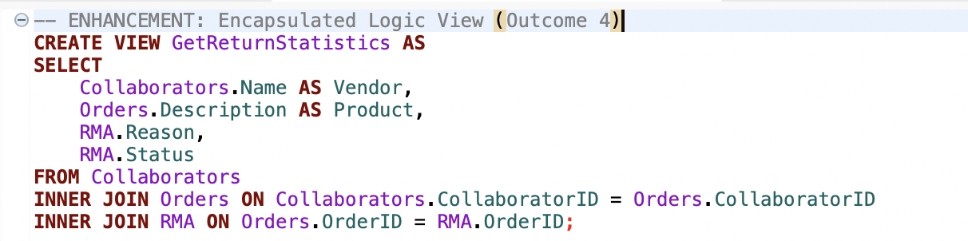
To improve the artifact, I implemented a database view called GetReturnStatistics, which encapsulates complex join logic between the Collaborators, Orders, and RMA tables. This enhancement improves readability, reusability, and maintainability by allowing users to access structured data without needing to rewrite complex SQL queries.
Figure 2. Secure data view filtering completed return records to limit unnecessary data exposure.
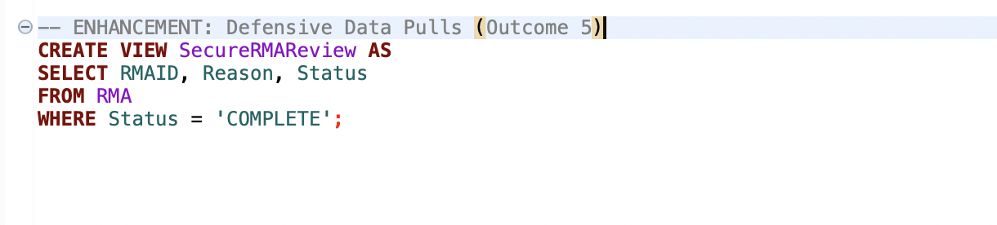
I also created a second view, SecureRMAReview, which applies filtering conditions to return only completed RMAs. This demonstrates defensive data access by restricting the dataset to only relevant and finalized records.

3. Did you meet the course outcomes you planned to meet with this enhancement in Module One? Do you have any updates to your outcome-coverage plans?
This enhancement aligns with Course Outcome 4, as I applied structured database techniques to improve system organization and usability. By implementing views, I demonstrated my ability to create reusable and efficient database components that support business analysis.
Additionally, this work supports Course Outcome 5, which focuses on developing a security mindset. The use of filtered views helps reduce unnecessary data exposure and ensures that only relevant information is accessible, which is a key principle in secure database design.

4. Reflect on the process of enhancing and modifying the artifact. What did you learn as you were creating it and improving it? What challenges did you face?
Through this enhancement, I gained a stronger understanding of how database abstraction can improve both usability and security. My experience in software testing has shown me that complex queries can lead to errors and inconsistencies if they are repeatedly rewritten, and using views helps standardize data access.
One challenge I encountered was ensuring that the joins and filters within the views returned accurate and meaningful results. I had to carefully test the relationships between tables to confirm that the output reflected the intended business logic.
Overall, this process reinforced the importance of designing databases that are not only functional but also maintainable and secure. By implementing views, I was able to improve the structure of the database while also demonstrating a more professional approach to data management.

